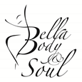
Bella Body & Soul Adult Enrolment & Pre-Exercise Screening
Name:
Address:
Age : D.O.B:
Contact Number: (Wk) (Hm) (Mob)
E-mail Address (for newsletters & important information):
Facebook Profile Name or Messenger(for group chats):
*(If you are not on Facebook please download Messenger App-find Bella Body & Soul or Renee Sloan)
Classes Attending:
Have you had any related experience in dance in the past? Yes[ ] No [ ] Details:
Describe your current physical activity/exercise levels/frequency/duration:
Two Emergency Contacts:
(1) Name Relation
(Ph)
(2) Name Relation
(Ph)
Questions need to be answered to identify those with a known disease, or signs/symptoms, who may be a higher risk of an adverse event during exercise. This is self-administered & self-evaluated. This also will assist with appropriate exercise prescription.
Medical History Check: Have you any medical history, recent injuries, surgery within past 12months, pregnancy or allergies, conditions or additional needs that Bella Body & Soul should be aware of? (Such as asthma, bees, blood pressure or bad back, epilepsy/seizures etc.) Yes[ ] No [ ] please specify

Family History of heart disease, stroke, heart attack? Specify relative& age

Do you smoke cigarettes on a daily basis or weekly or have you quit within last 6 months? Yes No specify
If currently smoking, how many per day or week? specify
Please Note:If you have answered yes to any of above a doctor’s recommendation or from other allied health professionals or yes to questions 1-9 Screening tool questionnaire; action plan or medical clearance is required. We will discuss what adjustments will be needed to be made. Should you suffer from any illness, injury or condition in the future, please advise the instructor on arrival of class.
If you have answered No to all questions and you have no other concerns about your health then you can proceed to undertake moderate to high intensity physical exercise.
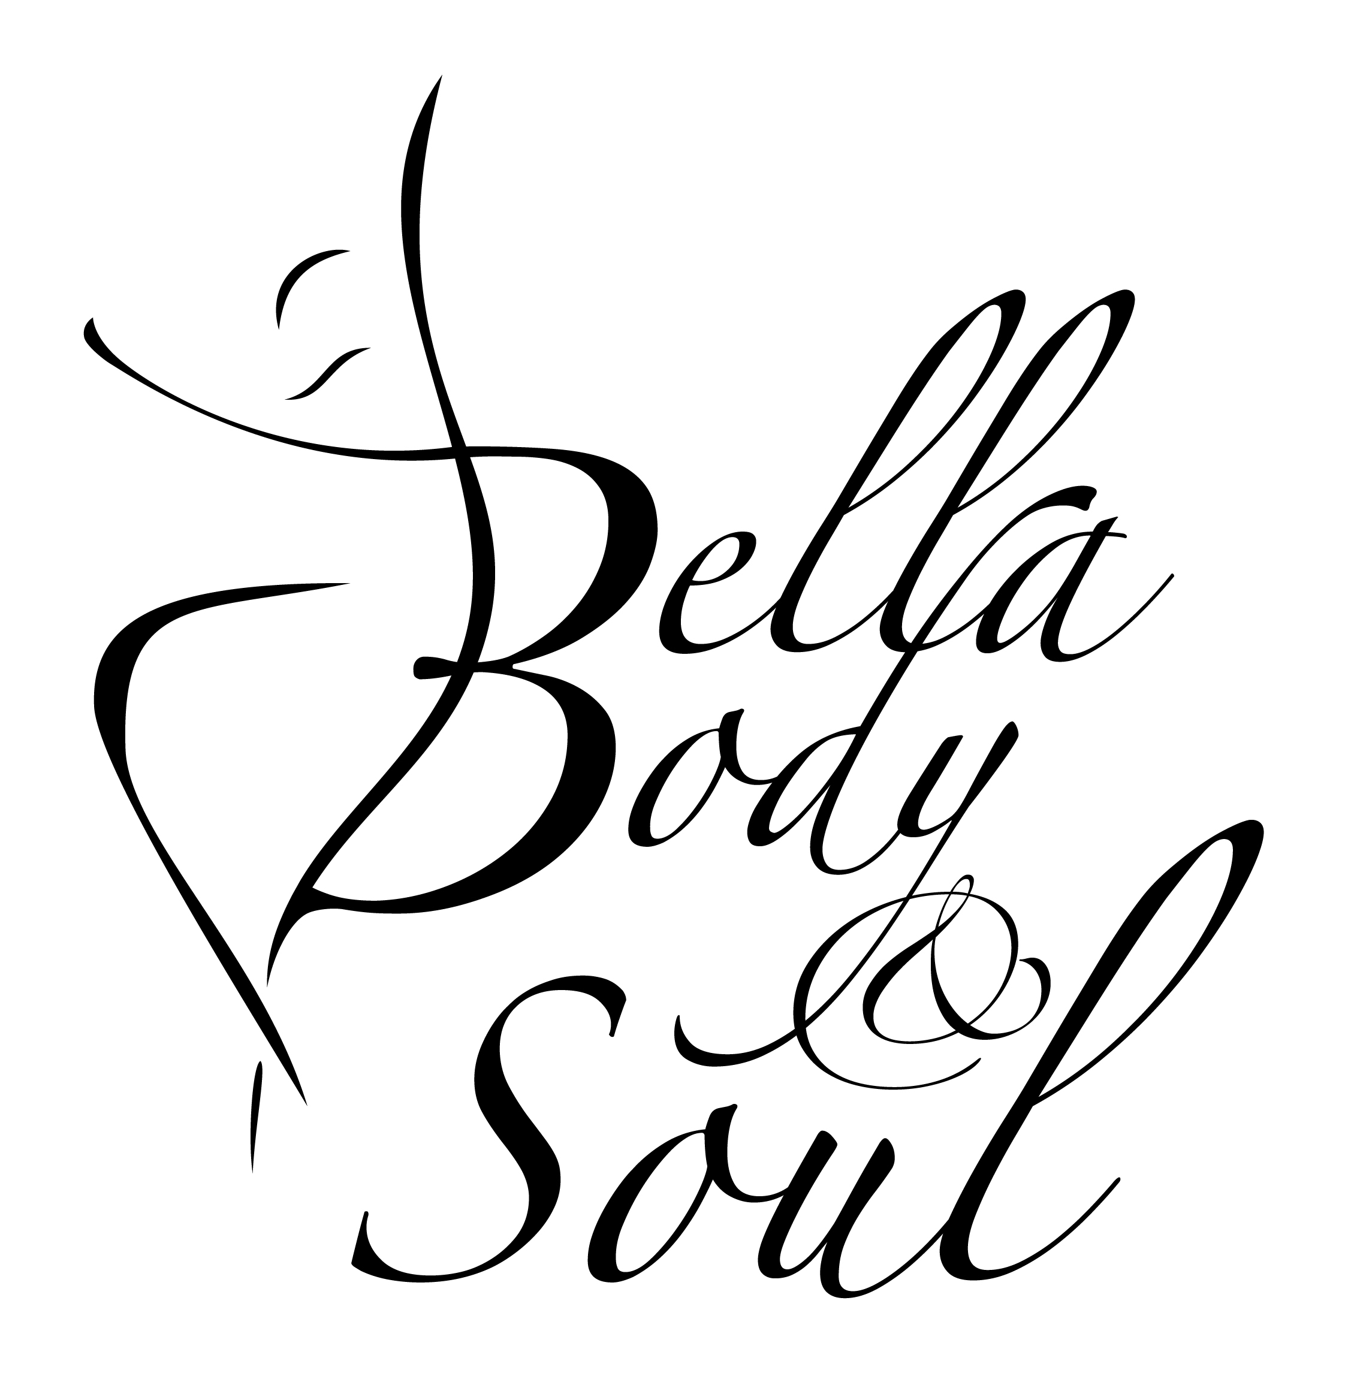
Bella Body & Soul Questionnaire/Screening tool
*1. Have you ever had a heart attack, coronary revascularisation surgery or a stroke? N o Ye s

*2. Has your doctor ever told you that you have heart trouble or vascular disease? N o Ye s

*3. Has your doctor ever told you that you have a heart murmur? N o Ye s

*4. Do you ever suffer from pains in your chest, especially with exercise? N o Ye s

*5. Do you ever feel faint or have spells of severe dizziness, particularly with exercise that may cause you to lose balance? N o Yes

*6. Do you have high or low blood pressure? No Yes (please specify)

*7. Do you have diabetes [IDDM or NIDDM] ? specify
If so, do you have trouble controlling your diabetes? N o Ye s

*8. Do you have chronic obstructive pulmonary disease, interstitial lung disease,
or cystic fibrosis? N o Ye s

*9. Have you any diagnosed muscle, bone or joint problems that you have been told could worsen by participating in physical exercise/activity? ? N o Ye s

10. Do you ever get pains in your calves, buttocks or at the back of your legs
during exercise which are not due to soreness or stiffness ? N o Ye s

11. Do you experience swelling or accumulation of fluid about the ankles? N o Ye s

12. Do you ever get the feeling that your heart is suddenly beating faster, racing or
skipping beats, either at rest or during exercise ? N o Ye s

13. Have you ever had an attack of shortness of breath or asthma attack that developed when you at any time were in the last 12 months ? N o Ye s

14. Have you ever had an attack of shortness of breath that developed after you
stopped exercising, at any time in the last 12 months ? N o Ye s

15. Have you ever been woken at night by an attack of shortness of breath, at any
time in the last 12 months ? N o Ye s

16. Do you have any ulcerated wounds or cuts on your feet that do not seem to heal? N o Yes

17. Do you have any liver, kidney or thyroid disorders? N o Yes

18. Do you experience unusual fatigue or shortness of breath with usual activities? N o Ye s

19. Do you have high cholesterol? No Yes specify level:

20. Is there any other physical reason or medical condition, or are you taking any
medication(s) which could prevent you from undertaking an exercise program, or
that you are concerned about? # N o Yes specify:

I believe that to the best of my knowledge, all of the information I have supplied within this tool is correct
Name: Signature: Date:

Bella Body & Soul ACCIDENT WAIVER AND RELEASE OF LIABILITY FORM
Name of the Activity or Event: Bella Body & Soul Dance lessons
Date of Activity or Event:

I HEREBY ASSUME ALL OF THE RISKS OF PARTICIPATING AND/OR VOLUNTEERING IN THIS
ACTIVITY OR EVENT, including by way of example and not limitation, any risks that may arise from negligence or carelessness on the part of the persons or entities being released, from dangerous or defective equipment or property owned, maintained, or controlled by them, or because of their possible liability without fault.

I certify that I am physically fit, have sufficiently prepared and must follow instructions or rules relating to Bella Body & Soul for participation in the activity or event, and have not been advised to not participate by a qualified medical professional. I certify that there are no health related reasons or problems which preclude my participation in this activity or event.
I acknowledge that this Accident Waiver and Release of Liability Form will be used by the event holders, sponsors, and organisers of the activity or event in which I may participate, and that it will govern my actions and responsibilities at said activity or event.

In consideration of my application and permitting me to participate in this event, I hereby take action for myself, my executors, administrators, heirs, next of kin, successors, and assigns as follows:

(A) I WAIVE, RELEASE, AND DISCHARGE from any and all liability, including but not limited to, liability
arising from the negligence or fault of the entities or persons released, for my death, disability, personal injury,
property damage, property theft, or actions of any kind which may hereafter occur to me including my traveling to and from this event, THE FOLLOWING ENTITIES OR PERSONS: Bella Body & Soul, Renee Sloan and/or their directors, officers, employees, volunteers, representatives, and agents, the activity or event holders, activity or event sponsors, activity or event volunteers;

(B) I INDEMNIFY, HOLD HARMLESS, AND PROMISE NOT TO SUE the entities or persons mentioned in this paragraph from any and all liabilities or claims made as a result of participation in this activity or event, whether caused by the negligence of release or otherwise.
I acknowledge that the Bella Body & Soul, Renee Sloan and their directors, officers, volunteers, representatives, and agents are NOT responsible for the errors, omissions, acts, or failures to act of any party or entity conducting a specific event or activity on behalf of the Bella Body & Soul.

I acknowledge that this activity or event may involve a test of a person’s physical and mental limits and may carry with it the potential for death, serious injury, and property loss. The risks may include, but are not limited to, those caused by terrain, facilities, temperature, weather, condition of participants, equipment, vehicular traffic, actions of other people including, but not limited to, participants, volunteers, spectators, coaches, event officials, and event monitors, and/or producers of the event, and lack of hydration. These risks are not only inherent to participants, but are also present for volunteers.

I hereby consent to receive medical treatment which may be deemed advisable in the event of injury, accident,
and/or illness during this activity or event.

I understand that at this event or related activities, I may be photographed. I agree to allow my photo, video, or film likeness to be used for any legitimate purpose by the event holders, producers, sponsors, organisers, and assigns.

The accident waiver and release of liability shall be construed broadly to provide a release and waiver to the
maximum extent permissible under applicable law.

I CERTIFY THAT I HAVE READ THIS DOCUMENT, AND I FULLY UNDERSTAND ITS CONTENT. I AM AWARE THAT THIS IS A RELEASE OF LIABILITY AND A CONTRACT AND I SIGN IT OF MY OWN FREE WILL.

Print Participant’s Name: Age:
Signature: Date:

Bella Body & Soul TERMS AND CONDITIONS

I agree to abide by fee terms: to pay non-refundable registration fee prior to first class and class fee’s payment by the term fee policy or if applicable prior to commencement of each class or and that there are NO REFUNDS on any payment or for missed classes or make up classes (if classes are missed due to the studio payment will go towards next term).
If fees are not paid prior to each class I will be unable to attend class unless I have made suitable arrangements with the teacher to organise payment.
I agree to abide by the Terms & conditions and Code of Conduct set out by Bella Body & Soul. By signing the Accident waiver and Release of liability form you are giving consent for Bella Body & Soul to use photographs and/or video footage for promotional purposes e.g. website, newspapers, events, or shopping centres (please note: individuals will not be named unless permission has been granted. Original photographs/videos taken by staff are held securely at the postal premises of Bella Body & Soul.
I agree to supervision requirement whilst on the premises and agree to pay for any damages/breakages that may occur.
I acknowledge that the premise is a Non-smoking area and will not attend class whilst under the influence of any drugs or alcohol.
Bella Body & Soul’s instructor will guide me into exercises which are suitable to my own ability & concentration. I understand to provide adequate dance tuition it is necessary for dance teachers to guide students movement, which may require physical contact.
During the period of participation within Bella Body & Soul, I understand that it is my responsibility to advise Bella Body & Soul of any changes to any personal circumstances/information.
Name: Signature: Date:
Witness Name: Renee Sloan Signature: Date:

