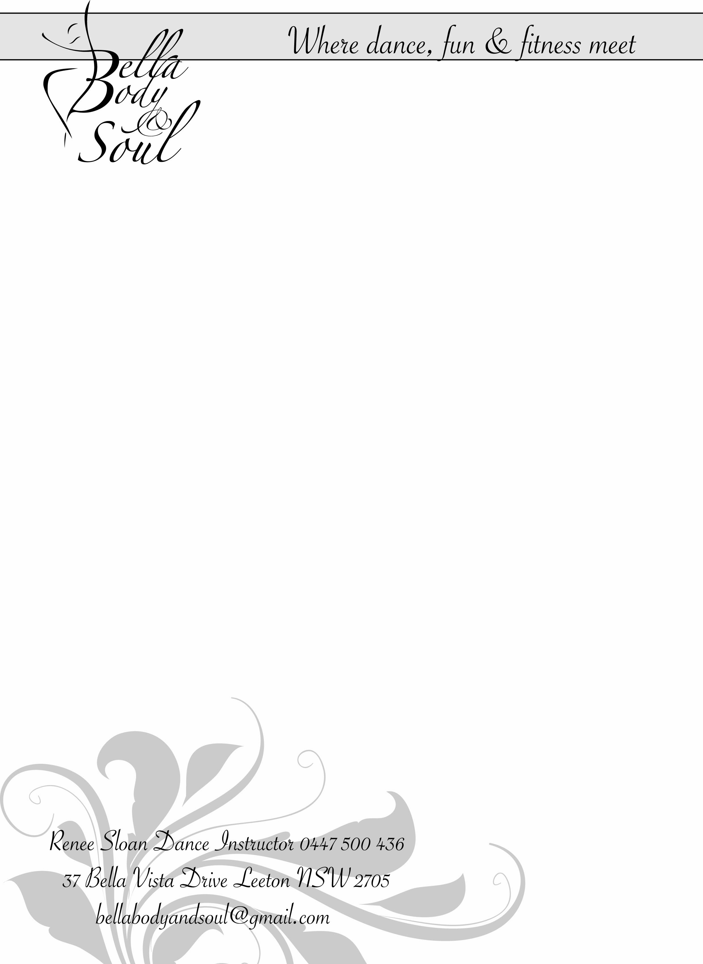

**EXERCISE INTENSITY GUIDELINES**

|  |  |  |  |
| --- | --- | --- | --- |
| **Intensity Category** | **Heart Rate Measures** | **Perceived Exertion Measures** | **Descriptive Measures** |
| Sedentary | <40% HRmax | Very, very light  RPE# <1 | • Activities that usually  involve sitting or  lying and that have  little additional  movement and a low  energy requirement |
| Light | <4 TO <55 0% HRmax | Very Light to light  RPE# 1-2 | • An aerobic activity  that does not cause a  noticeable change in  breathing rate  • An intensity that can  be sustained for at  least 60 minutes |
| Moderate | <55 TO <70% HRmax | Moderate to somewhat hard  RPE# 3-4 | • An aerobic activity  that is able to be  conducted whilst  maintaining a  conversation  uninterrupted  • An intensity that may  last between 30 and  60 minutes |
| Vigorous | <70TO <90% HRmax | Hard  RPE# 5-6 | • An aerobic activity in  which a conversation  generally cannot  be maintained  uninterrupted  • An intensity that may  last up to about 30  minutes |
| High | >90% HRmax | Very hard  RPE# >7 | • An intensity that  generally cannot be  sustained for longer  than about  10 minutes |

#=Borgs Rating of Perceived exertion (RPE) SCALE, CATEGORY 1-10